**Performace exam:**

**EVERYONE MUST DO THE FIRST THREE**

|  |  |
| --- | --- |
|  | Make a rectangle  HTML:  CSS: |
|  | Make a Lemon  HTML:  CSS: |
|  | Make a Circle  HTML:  CSS: |
|  | CHALLENGE 1 +5pts  Make a rainbow  HTML:  CSS: |
|  | CHALLENGE 2 +15pts  Neapolitan icecream  HTML:  CSS: |
|  | CHALLENGE 3 +25pts  Morph the square  HTML:  CSS: |

**SUPER EXTRA CREDIT CHALLENGE BONUS GUMBALL: +100 points**

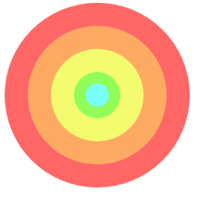

HTML:

CSS:

Hint:

In the css side use to center the circles:

position: absolute;

top: 50%; left: 50%;

transform: translate(-50%,-50%);